Practical No 5

AIM :- Use WireShark sniffer to capture network traffic and analyze
STEP 1: Install and open WireShark
STEP 2: Select Interface option (ETHERNET)
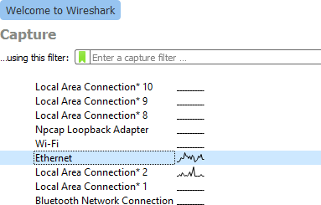

STEP 3: The source, Destination and protocols of the packets in the LAN network are displayed.
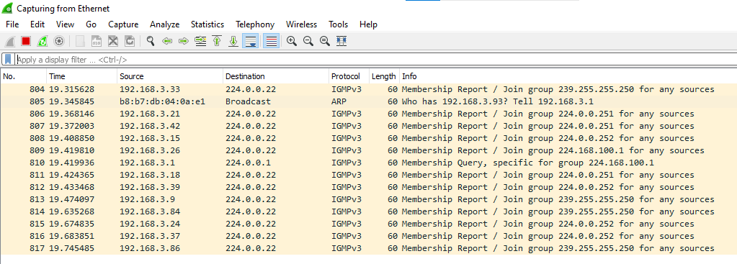
STEP 4: Open a website in a new window and enter the credentials and then sign in. Register if needed.


STEP 5: The Wireshark tool will keep recording the packets.
STEP 6: Select filter as http to make the search easier and click on apply.
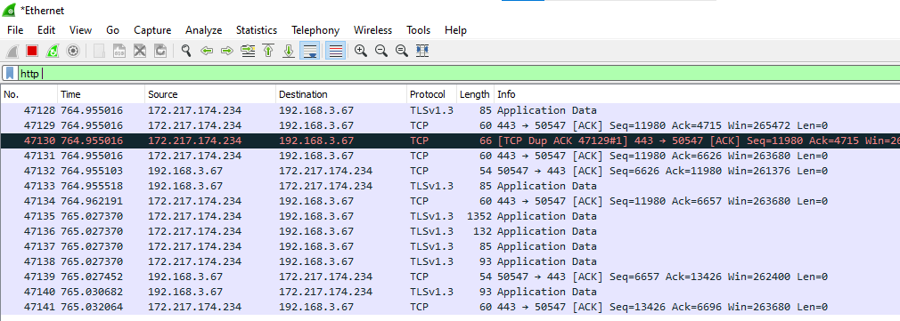
STEP 7 : Find the post methods for username and passwords.
